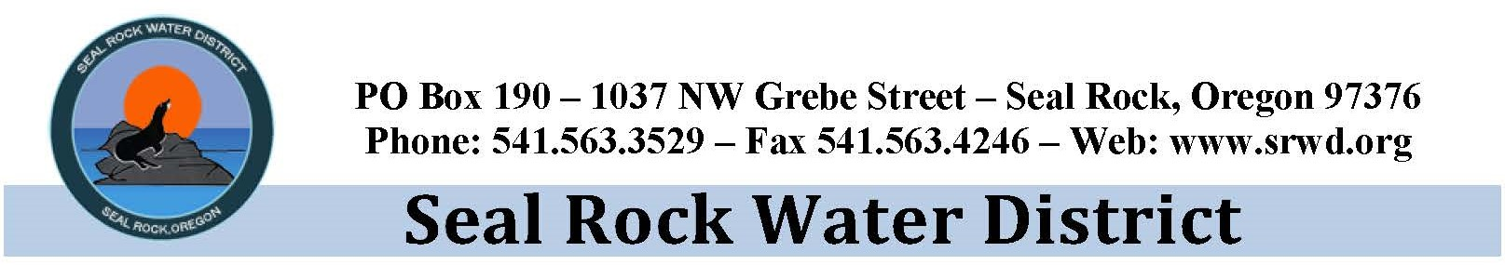

PUBLIC NOTICE
Website

Public Notice
Seal Rock Water District

The Board of Seal Rock Water District (SRWD)
located at 1037 NW Grebe Street, Seal Rock, Oregon
will hold a regular meeting on
Thursday, February 11, 2021 at 4:00 p.m.

Due to the Governor’s Executive Order related to public gatherings and to promote physical social separation guidelines currently in place at the federal and state level, the District will hold this meeting through ZOOM Video Conferencing. In the event of a meeting venue change, the District will notify the public by updating the website: www.srwd.org. The Public is invited to attend the meeting electronically. Please E-mail tkarlsen@srwd.org to receive the meeting login information. SRWD encourages the public to submit written comments on items included in the agenda by email to tkarlsen@srwd.org by 2:00 p.m. the day of the meeting to be included in the record. Comments received will be shared with the SRWD Board of Commissioners and included in the permanent record.

The agenda for the meeting will include, Consent Calendar; Primary Source Water Project Update; Staff Reports, and other Business from the Board.

In addition, the Board may convene an Executive Session under ORS 192.660(2)(h); to consult with legal counsel concerning the legal rights and duties of a public body with regards to current litigation or litigation likely to be filed.

Thank You
Joy S King

