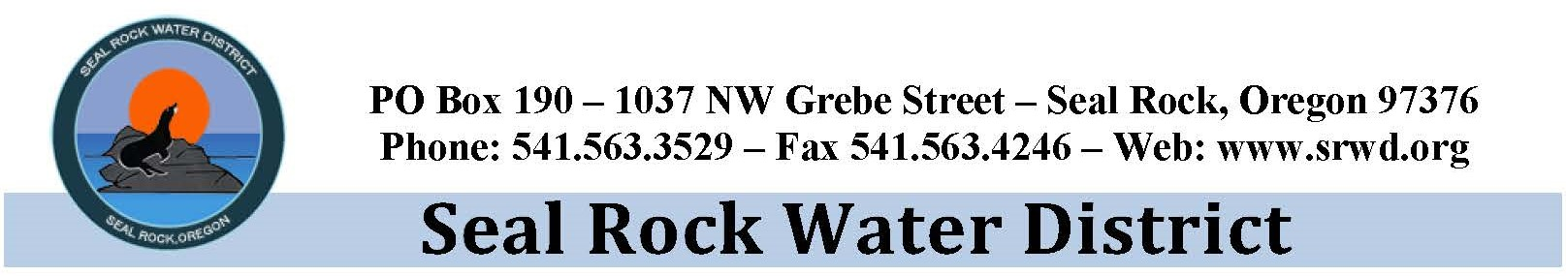
General Manager’s Report:
Board Meeting June 11, 2020

This report is an executive summary provided with this Board agenda to Commissioners with recommended actions if any. Detailed information, staff reports, and supporting materials are provided within the full agenda packet.

Phase-4 Source Water Project:
District staff and engineer along with funding partners form USDA-RD met with R&G Excavating to conduct the Beaver Creek Source Water Improvement project walkthrough on June 1, 2020. The project walkthrough included visiting every site and walking the pipeline route from North Beaver Creek Road to the Makai Community. Attendees were reminded that Beaver Creek area is very popular. We can expect much traffic on Beaver Creek roads. Traffic control will be extremely important. Contractor provided a three-week schedule which included staging and site preparation mostly at the intake site. Other items highlighted during the meeting included:

- R&G Excavating solely responsible for site safety, per the General Conditions 7.12. R&G shall designate a qualified safety representative.
- CPI/Pioneer shared trenching and Phone Materials Delivery.
- Schedule of materials submittal review is ongoing.
- No contamination of river or other permit violations
- Highly important to minimize changes to the project
- High-quality installation to provide decades of service
- Appropriate level of paperwork—regular communication to maintain clarity of work, to avoid delays, and to avoid surprises, but not so much paperwork that it becomes inefficient for all
- Timely communication on submittals and questions
- All contract documents have been executed and are in review by USDA-RD
- USDA-RD Sub-grant funding request was approved.

COVID-19 District Response:
The district continues to comply with Governor, Kate Brown’s Executive Orders, and the LC Phase-1 reopening. The district office opened to the public on June 1st with limited access. We continue to encourage customers and staff to follow the CDC recommendations on social distancing by avoiding public spaces and limiting personal contact in the community. Out of an abundance of caution, the following protocols will continue to be followed:

- All non-essential meetings of 10-persons or more will be held using the district video conference call system.
- June Regular Board Meeting will be hosted by video conference call.
- All non-essential travel by district representatives has been canceled.
- SRWD is encouraging district staff and customers to practice social distancing and follow measures provided by the CDC to stop the spread of coronavirus.
- Customers are encouraged to pay their bill online at www.XpressBillPay.com or call 1-855-603-9201,
use our payment drop box located outside our office at 1037 NW Grebe Street or mail payments to our PO Box 190, Seal Rock, OR 97376. Customers are also encouraged to enroll in the My Water Usage Customer Portal at biy.ly/mywaterusage.
- Temporary immediate suspension of delinquent turn-offs through the May billing cycle. This action been reevaluated, and the district has contacted those customers that are behind, encouraging them to make payment arrangements.
- Late fees and turn off/on fees have been suspended through May 2020.

Implementing these measures will reduce exposure to COVID-19 for our customers and staff. Like most municipal water suppliers throughout the state, we do not anticipate any disruption in service. We encourage anyone interested in learning more to please visit the CDC website for more information and updates on COVID-19 at www.cdc.gov/COVID19. We look forward to everyone staying healthy and getting back to normal as soon as possible.

Other notable activities for the month include:
- May 14th attended webinar on global pandemic effects on water system.
- May 29th provided testimony to the State House Water Committee on the economic impacts on small water districts in Oregon.
- On May 21st hosted the annual SRWD Budget meeting.
- Attended on-site Beaver Creek water quality field data collection with GSI Consultants.
- May 26th met with representative regarding small subdivision development on Wenger Lane.
- Worked with general and special counsel regarding easement agreements.
- May 28th attended the Oregon Water Utility Council (OWUC) monthly meeting.
- Provided input to SDAO Legislative Committee regarding a joint letter to Members of the Joint Special Committee on Coronavirus at the state capitol.
- Met with representative from OWRD to discuss transition of the Mid-Coast Water Planning Partnership.
- Worked with Jacobs and USDA-RD to complete the EJCDC E-500 engineer/owner service agreement.
- Attended several video conferences with engineers, contractor, and USDA to discuss submittals and schedule for on-site work.
- Attended several meetings with OWRD representatives to discuss transition of the MC-WPP from the City of Newport to the District, and to review proposals for hiring a planning facilitator.

