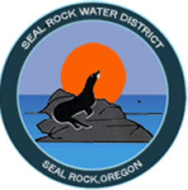 NEWS RELEASE
FOR IMMEDIATE RELEASE
CONTACT: Adam Denlinger
O: 541.563.3529 | F: 541.563.4246
adenlinger@srwd.org
Seal Rock Water District
Funding Awarded $11.9M
For Source Water Improvements

SEAL ROCK, Oregon (July 16, 2019) – The United States Department of Agriculture Rural Development (USDA-RD) announced today an award of $11.9 million in funding to the Seal Rock Water District (SRWD) to complete needed source water improvements between now and 2021.

This funding provided by the USDA-RD is the most recent award in a long-term, strategic effort of SRWD to leverage the revenue dollars of its small community and increase the potential impact of improvements to Seal Rock’s lengthy water system. This pledge has led SRWD to successfully acquire over $15M in partner funding in the last two years:

United States Department of Agriculture - Rural Development 2019:
Loan amount: $9,096,000
Grant Amount: $2,799,500
Total Package: $11,895,500

Business Oregon - Infrastructure Finance Authority, Safe Drinking Water Revolving Loan Fund 2018:
Loan Amount: $2,451,000
Grant Amount: $1,030,000
Total Package: $3,481,000

The District is very pleased with such a positive outcome from months of advanced planning, hard work and commitment on the part of the District’s Board of Commissioners, consultants and staff. In this challenging economy, tapping external resources and partnerships to promote sustainability in developing a more resilient source water supply system Is absolutely critical. Funding from grants like these allow SRWD to offer our customers even more value for their dollar. The District’s success and positive grant pursuits is largely due to the highly collaborative efforts of the SRWD Board of Commissioners and our partners from USDA-RD and Business Oregon-IFA. “With their consideration and support of District improvements, we will continue to provide reliable safe drinking water to the Seal Rock community for generations to come.”

- end -

